**WEEK 8 GIT**

**EXERCISE 1:**

1. Check if Git is installed:

git –version

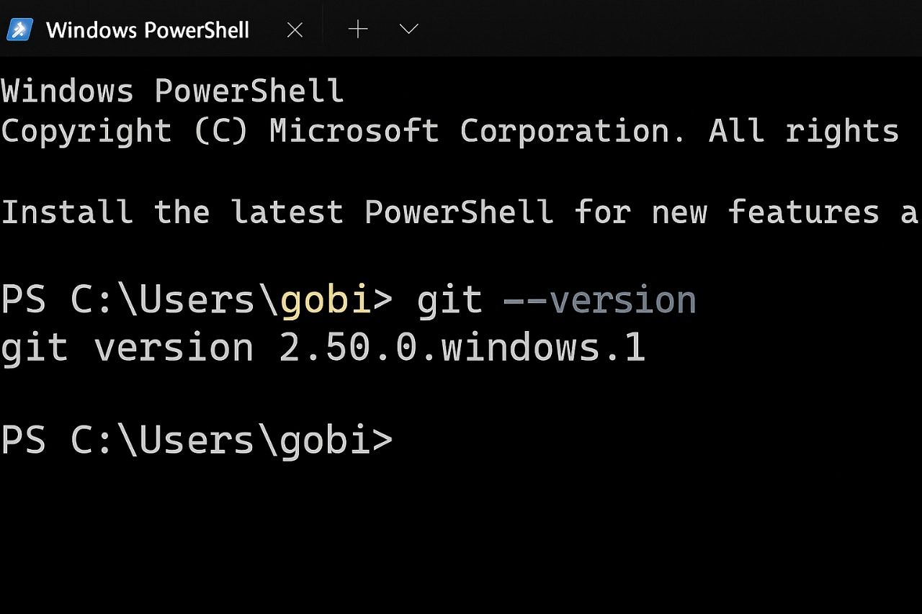

2. Set up Git global user config:

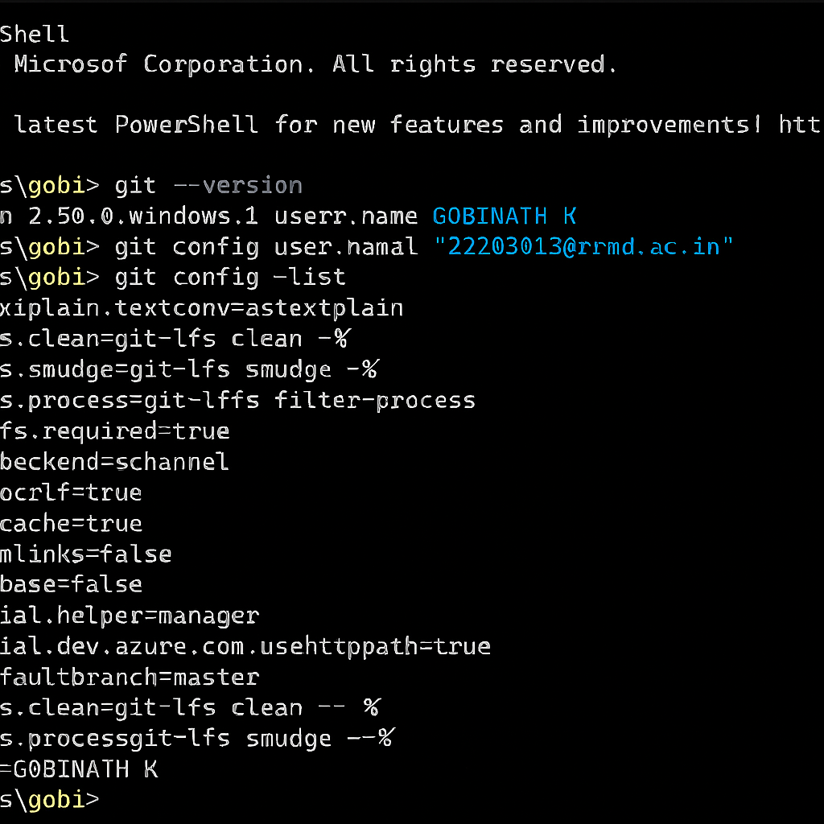

3. Confirm configuration:

git config –list

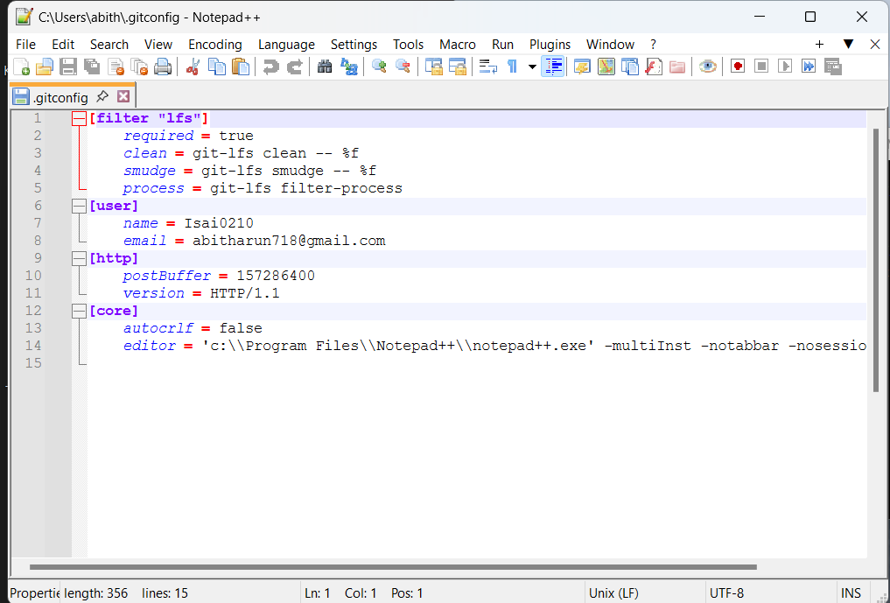

1. Create project folder and initialize Git:

* mkdir GitDemo
* cd GitDemo
* git init

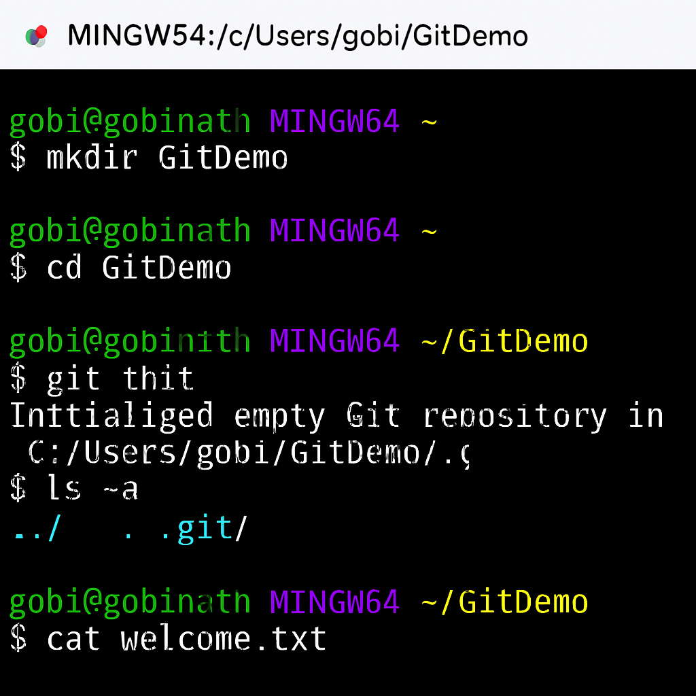

2. Verify Git repo is initialized:

* ls -a

3. Create and edit a file:

* notepad++ welcome.txt

4. Check the file exists:

* ls

5. View the content:

* cat welcome.txt

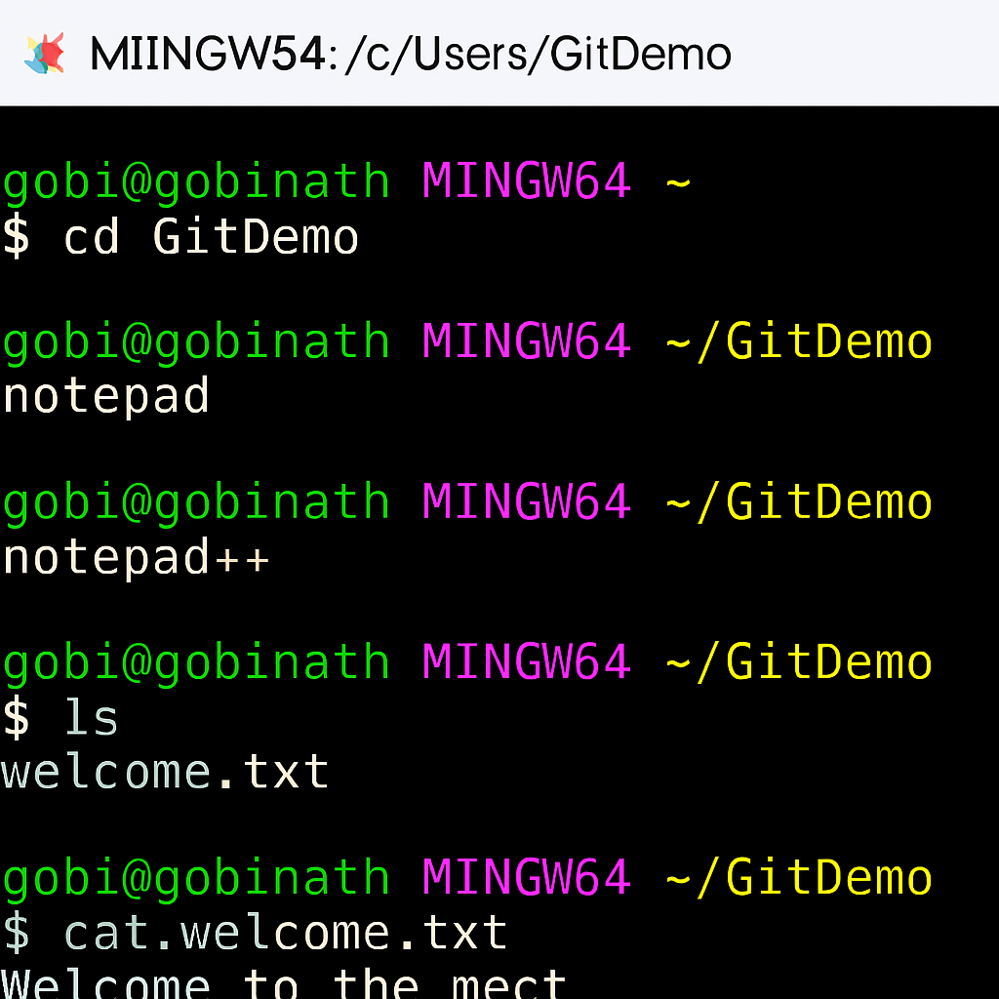

6. Check Git status:

* git status

7. Stage the file:

* git add welcome.txt

8. Commit with multiline message (opens Notepad++):

* git commit

9. Confirm file is committed:

* git status

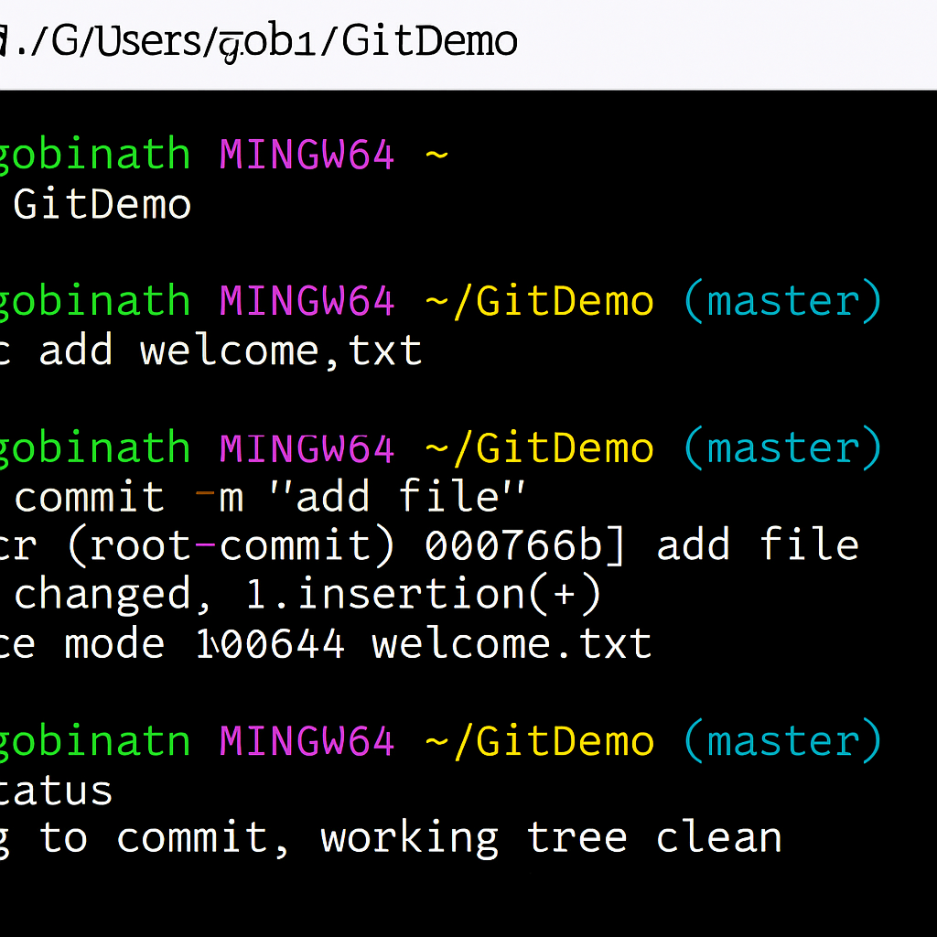

Connect to Remote Repository:

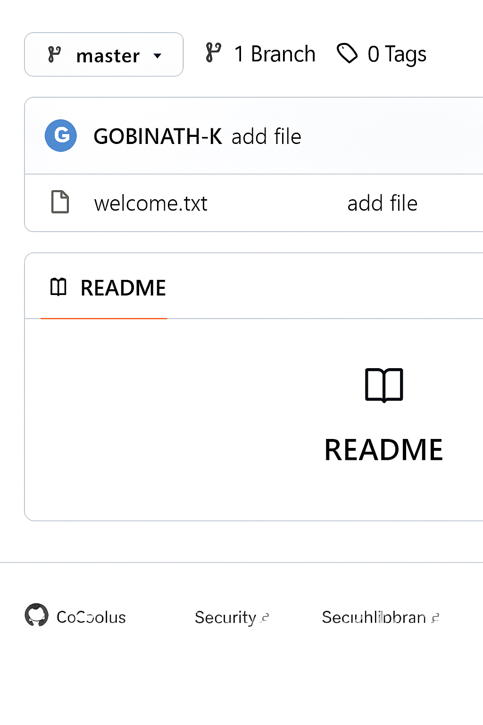

**EXERCISE 2:**

cd ~/GitDemo

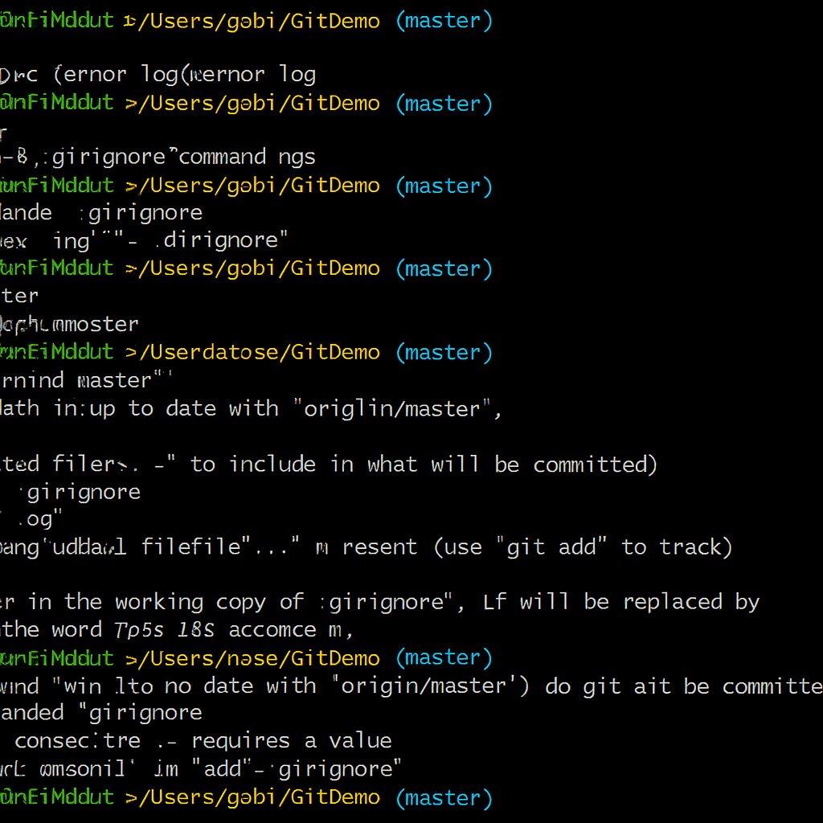

Create test files and folder to ignore

* echo "error log" > error.log

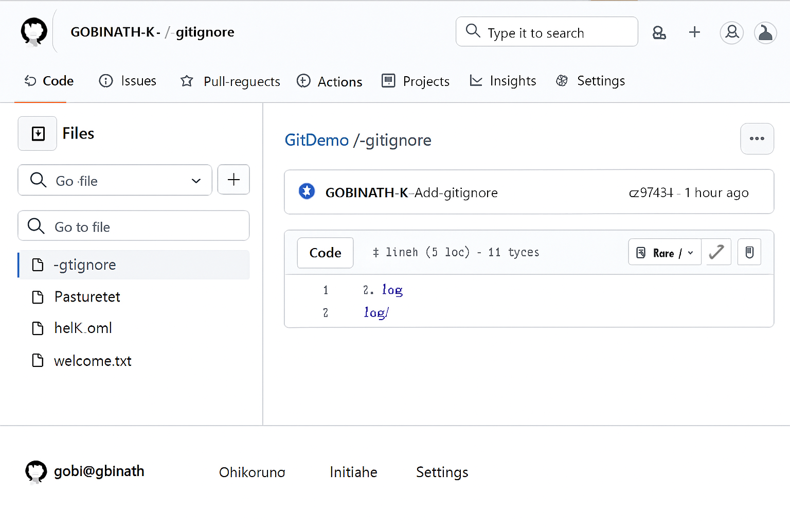

* mkdir log
* echo "log content" > log/system.log

Create a .gitignore file

* touch .gitignore
* echo "*.log" >> .gitignore
* echo "log/" >> .gitignore
* *.log
* log/

Check Git status

* git status



Add and commit only .gitignore

git add .gitignore

git commit -m "Add .gitignore to ignore .log files and log/ folder"



**EXERCISE 3:**

Create a new branch called GitNewBranch

git checkout -b GitNewBranch



List all branches

git branch

Add a new file in this branch

echo "This is a new feature file" > feature.txt

Stage and commit the file

git add feature.txt

git commit -m "Add feature.txt in GitNewBranch"

Check branch status

git status

MERGING

Switch back to the master branch

git checkout master

Check differences between master and GitNewBranch

git diff master..GitNewBranch



Merge GitNewBranch into master

git merge GitNewBranch

Delete the merged branch

git branch -d GitNewBranch

git status



**EXERCISE 4:**

Create a new branch GitWork and switch to it

git checkout -b GitWork

Add a file hello.xml and update its content

echo "<message>Hello from GitWork branch</message>" > hello.xml

Stage and commit the file

git add hello.xml

git commit -m "Added hello.xml from GitWork branch"

Switch back to master

git checkout master



Add a different version of hello.xml in master

echo "<message>Hello from master branch</message>" > hello.xml

Commit changes in master

git add hello.xml

git commit -m "Added hello.xml from master branch"

View logs in graph format

git log --oneline --graph --decorate –all



Check differences using CLI tool

git diff master GitWork



Merge GitWork into master

git merge GitWork

Commit after resolving conflict

git add hello.xml

git commit -m "Resolved merge conflict in hello.xml"



**EXERCISE 5:**

Verify if master is in clean state

git checkout master

git status

List all available branches

git branch -a

Pull latest changes from remote

git pull origin master

Push your local commits to remote

git push origin master



